Torphins Primary School

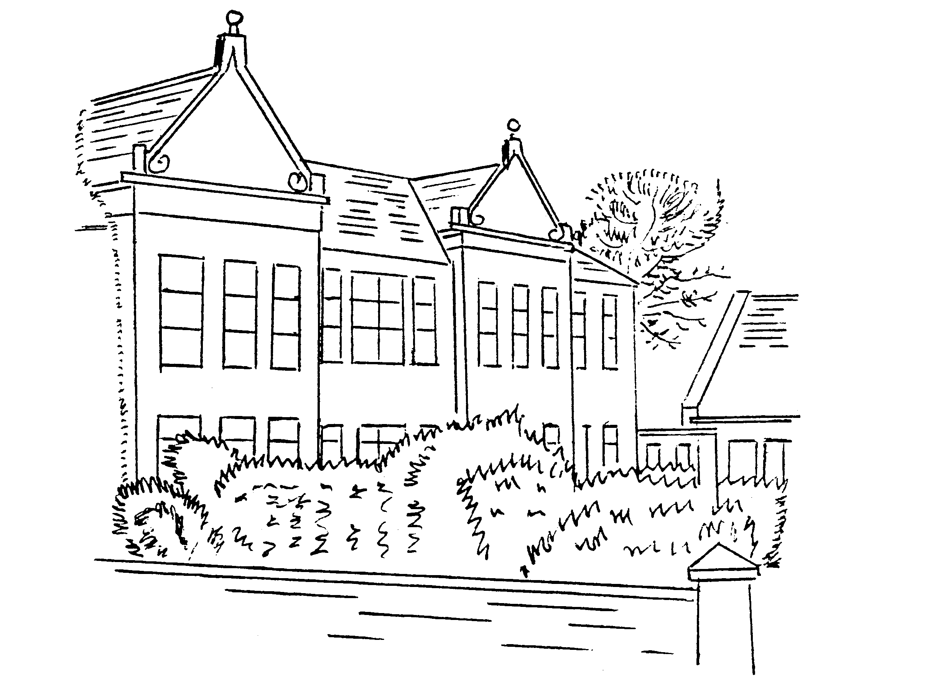

Vision, Values and Aims

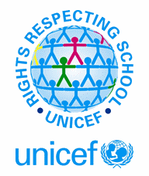
Rev 1 October 2016
Rev 2 March 2019
Rev 3 November 2019
Rev 4 March 2020

Learning Together Anything’s Possible

Article 12 Children have the right to say what they think should happen, when adults are making decisions that affect them, and to have their opinions taken into account.

Article 31 All children have the right to relax and play, and to join in a wide range of activities.

Torphins Primary School
Vision, Values and School Ethos

- We are a UNICEF Rights Respecting School and as Effective Contributors and Responsible Citizens we uphold its values.

- We embrace challenge and try our best in everything we do to become Successful Learners and Confident Individuals.

- Our school aims to make learning meaningful, appropriate to individual needs and enjoyable.

- We celebrate success and achievement gained both in school and in our wider community.

- We are proud of our school.
Article 29 Education should develop each child’s personality and talents to the full. It should encourage children to respect their parents, their own and others’ cultures.

Article 28 All children have a right to primary education which should be free. Wealthy countries should help poorer countries achieve this. Discipline in schools should respect children’s dignity. Young people should be encouraged to reach the highest level they are capable of.

Article 24 Children have a right to good quality health care, to clean water, nutritious food, and a clean environment, so that they will stay healthy.

