November Newsletter

Our Right's Respecting monthly value for November was friendship.  Last month we thought about our friends and what they meant to us.  We thought about what qualities made them WAGOLL friends and how we could show them we appreciate, respect and care for them. | 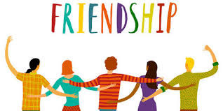

Here are some of Rights Respecting School activities that classes have been doing throughout November as we continue to work towards our Gold Award.

Nursery:
The Nursery children learnt all about why we wear poppies. They all drew a poppy onto a stone. We took them up to the Memorial and laid them with the other poppies. Mrs Elrick found a poppy on a lamp post and brought it in. It was for William Morgan. We learnt all about him and found his name written on the Memorial Stone.
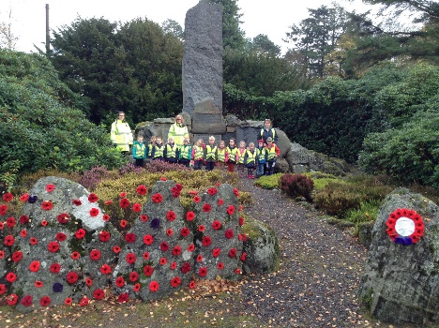
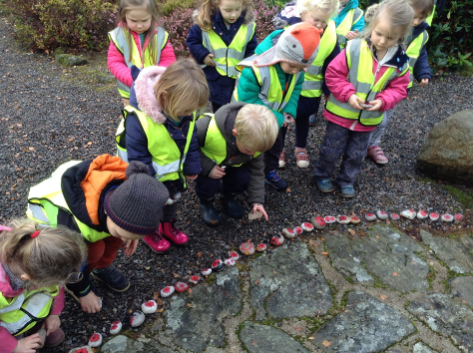

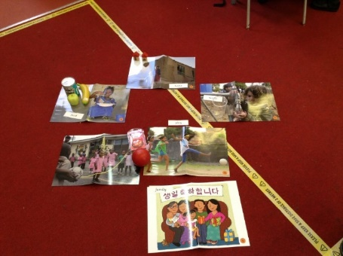
Primary 1:
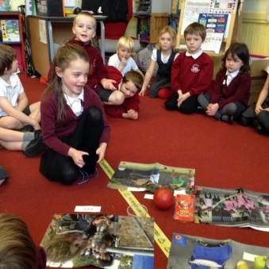
Article 1 - Primary 1 have been learning about needs and wants. The things that children need are called rights. All children in the world have rights. We sorted some pictures into what we thought was a need and what is a want. We decided needs included clean water, food, shelter, play and family. We looked at photos of children from around the world and guessed what right we thought they were showing.

Primary 2:
In November P2 have been focusing on Article 31 – the right to relax, play and take part in a wide range of activities.
* We have discussed how important playing with our friends is to us.
* We have talked about the different type of activities we like to do outside school that help us to have fun and relax
* On 13th November, we discovered what ‘Children in Need’ was all about and found out that some of the money raised goes to clubs and societies across the UK. This helps lots of children get the chance to take part in a wide variety of activities.

Primary 3:
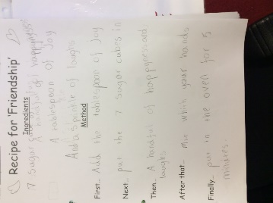
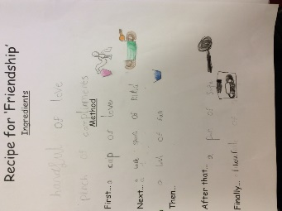
In Primary 3 we have been thinking about what ‘ingredients’ we need to make a ‘good friend’. Then we wrote ‘Recipes for Friendship’.

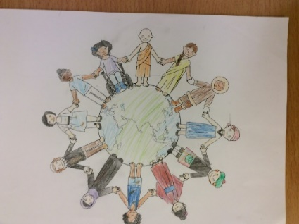
We have also been looking at ‘World Children’s Day’. We coloured in the world with all the different children from all the different backgrounds around the world.
In our class we have various children from different backgrounds, including American, Israeli, Chinese, and of course those who are of various religions too.

Primary 4:
Primary 4 have been looking at Article 12 - ‘Every child has the right to have a say in all matters affecting them and to have their views taking seriously.’
Fergus and Logan, the RRS Class Reps, have done a survey to find out all the different ways to have your say in P4. Our class uses these different ideas, and everyone feels listened to:
Hands up, email, picture card on desk, private talking, writing something down, chat to adult at break or lunch, chat to an adult during P4/5 extra play session, worry box and thumbs.
We are going to continue this lesson by hearing the story ‘Not Now Bernard’ and doing some follow up discussion and activities.

Primary 4/5:
One of the things Primary 4/5 have been working on, linked to World Children’s Day and the UN Global Goals, is ‘What I want the World to look like in 2030’ We made spider diagrams to note down our ideas then turned our ideas into mini books. We discussed all of the rights this related to.
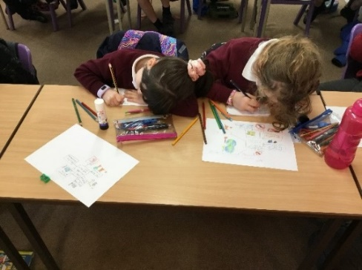
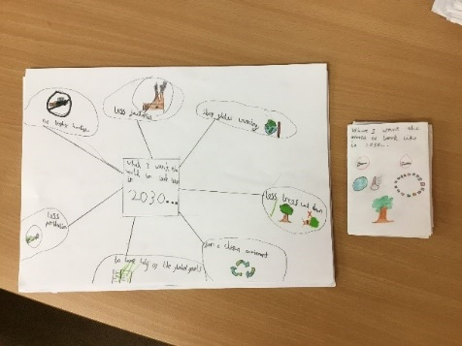

Primary 6:
Primary 6 have been working on Article 6 - Every child has the right to life. They debated what the difference was between things we want and things we need, if we are to survive and thrive. They also wrote about ‘What I want the world to look like in 2030’ and created postcards of the UN Global Goals which they want achieved by 2030. As Junior Road Safety Officers they also made clips about travelling to school safely to share with the school community. You can view these clips on the documents section of the main school newsfeed in Glow.
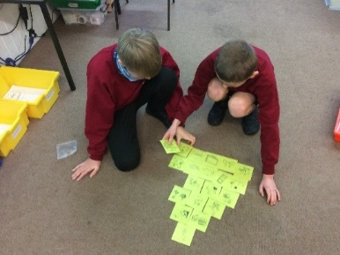
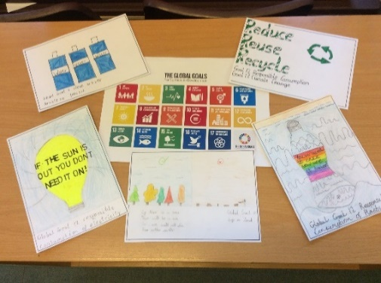
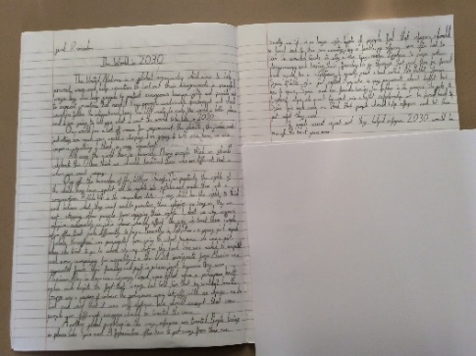

Primary 7:
P7 celebrated World Children’s Day on Tuesday. We discussed Article 1 (All children under 18 have all the rights in the Convention) and Article 4 (Making rights real: Governments must do all they can to make sure every child can enjoy their rights by creating systems and passing laws that promote and protect children’s rights). The children then drew their interpretation of the world they want to build after Covid19 and reimagined a greener more sustainable future for every child. The children also illustrated each of these five key rights in connection to climate change.
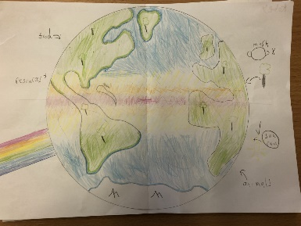
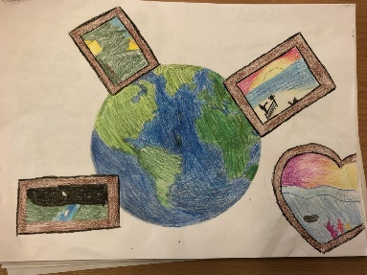
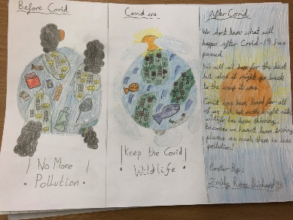

The articles for the week for P7 were Article 8 (Every child has the right to an identity. Governments must respect and protect that right, and prevent the child’s name, nationality, or family relationships from being changed unlawfully) and Article 38 (Governments must not allow children under the age of 15 to take part in war or join the armed forces. Governments must do everything they can to protect and care for children affected by war and armed conflicts). Through discussion and a quiz, the children discussed identity and child soldiers and then they designed their own poster against child soldiers.
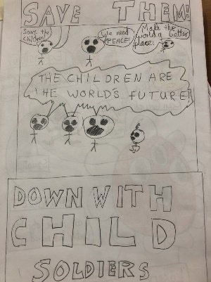
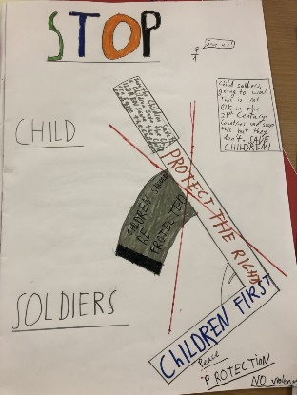
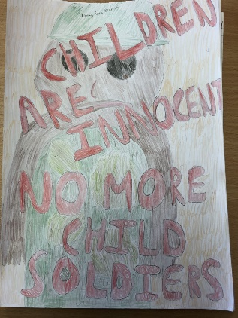

Pocket Book of Rights Home Activities
We hope that each family has got it’s ‘Pocket Book of Children’s Rights’ out of quarantine and is keeping it safe to use when the children are set regular activities, by their class teachers, to do as a family at home. They are trying to teach you about their rights so that you can be as committed to them as we are.

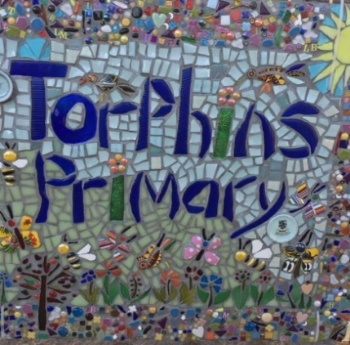 | Torphins School Parent Council  The TSPC have also been supporting us and showing their commitment to ensuring children’s rights in school, especially Articles 29 and 31.  They have already done some things to improve our school environment, including new planter seats and toys, and they have some more planned. Look out for a world map and some games being painted onto the playground.  They are also looking at purchasing some more ICT equipment and each class was given some money to spend on fun resources for the  classrooms. A big thank you to TSPC and our parents!

Our Right's Respecting monthly value for  December is thoughtfulness. This means considering other people’s feelings instead of just your own. There are many ways you can be thoughtful. You can give a gift or a compliment or advice. Think about how you can be thoughtful. Do something for someone in your family or one of your friends that displays thoughtfulness. Post your ideas on GLOW. | 