Our Lunch Hall Charter

We have the right to:
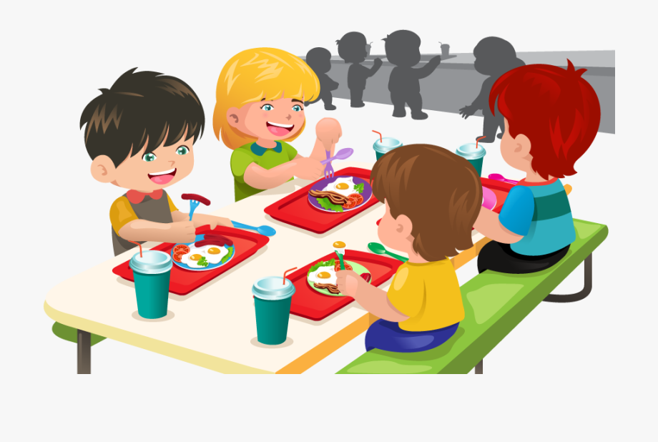
- Choose food from a healthy nutritious menu (Articles 6 and 24)

- Have clean water with our food (Article 24)

- A clean environment whilst eating so that we can enjoy our food (Article 24)

- Meet with other children where we can chat quietly with friends during our lunch (Articles 15 )

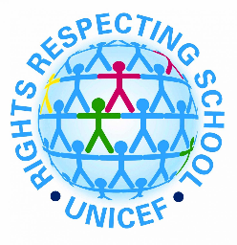
- Everyone has the right to be respected, including pupils and staff (Articles 12 and 13)

