Torphins Primary School

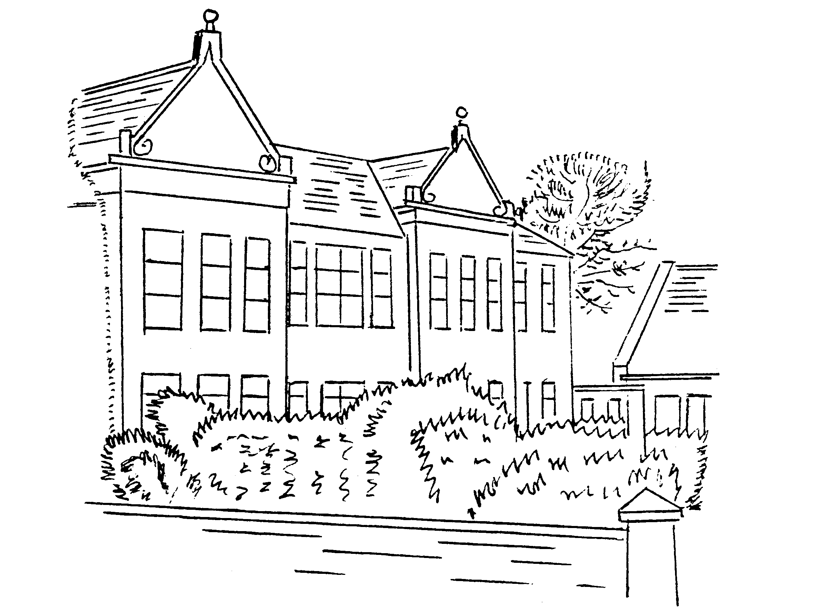

GLOW Community Rules
Policy Document


1. Nov 2014
2. Rev Nov 2019

Torphins Primary School
Article 16 Every child has the right to privacy.

Article 17 Every child has the right to reliable information from the media. This should be information that children can understand. Governments must help protect children from materials that could harm them.

GLOW Community Rules

Glow is an online tool to support learning and teaching.
Using Glow should be a positive experience. To help this, it is important that everyone takes responsibility for their actions online, the same as they would offline. These community rules are designed to help you use Glow in a sensible way.

Be Secure
- Always keep your Glow password to yourself.
- Always log out of Glow when no longer using it.

Be Polite
- Always treat others with respect on Glow.
- Never post a message or share content on Glow that is inappropriate or likely to cause harm or offence to others.

Be Safe
- Always remember to be careful when communicating over the internet – other users may not be who they seem.
- Don’t share your personal details with other people.
- Never agree to meet someone in person who you have only met on the internet unless accompanied by a parent, carer or other known and trusted adult.
- Always speak to an adult immediately if you see a message, image or anything else on the internet that concerns you.

Be Legal
- Never post or share content on Glow that you do not have permission to use.

Be Responsible
- Always be mindful that once you put something on Glow, that information may be beyond your control.
- Never post a message or share information on Glow that you would not wish other learners, teachers, or parents to see.
- Remember that anything you do on Glow may be traced back to you.
- If you misuse Glow, this may be reported to your school.

As with all internet activity, please remember to follow the guidance about internet safety provided by your school. If you are a learner and have a question or need advice, speak to a teacher. For further information about how to stay safe online, visit: http://ceop.police.uk/safety-centre/, CEOP’s online safety centre
www.respectme.org.uk, Scotland’s anti-bullying service.

In accordance with H2L2, Learning Through Technology Team guidelines.

