Torphins Primary School

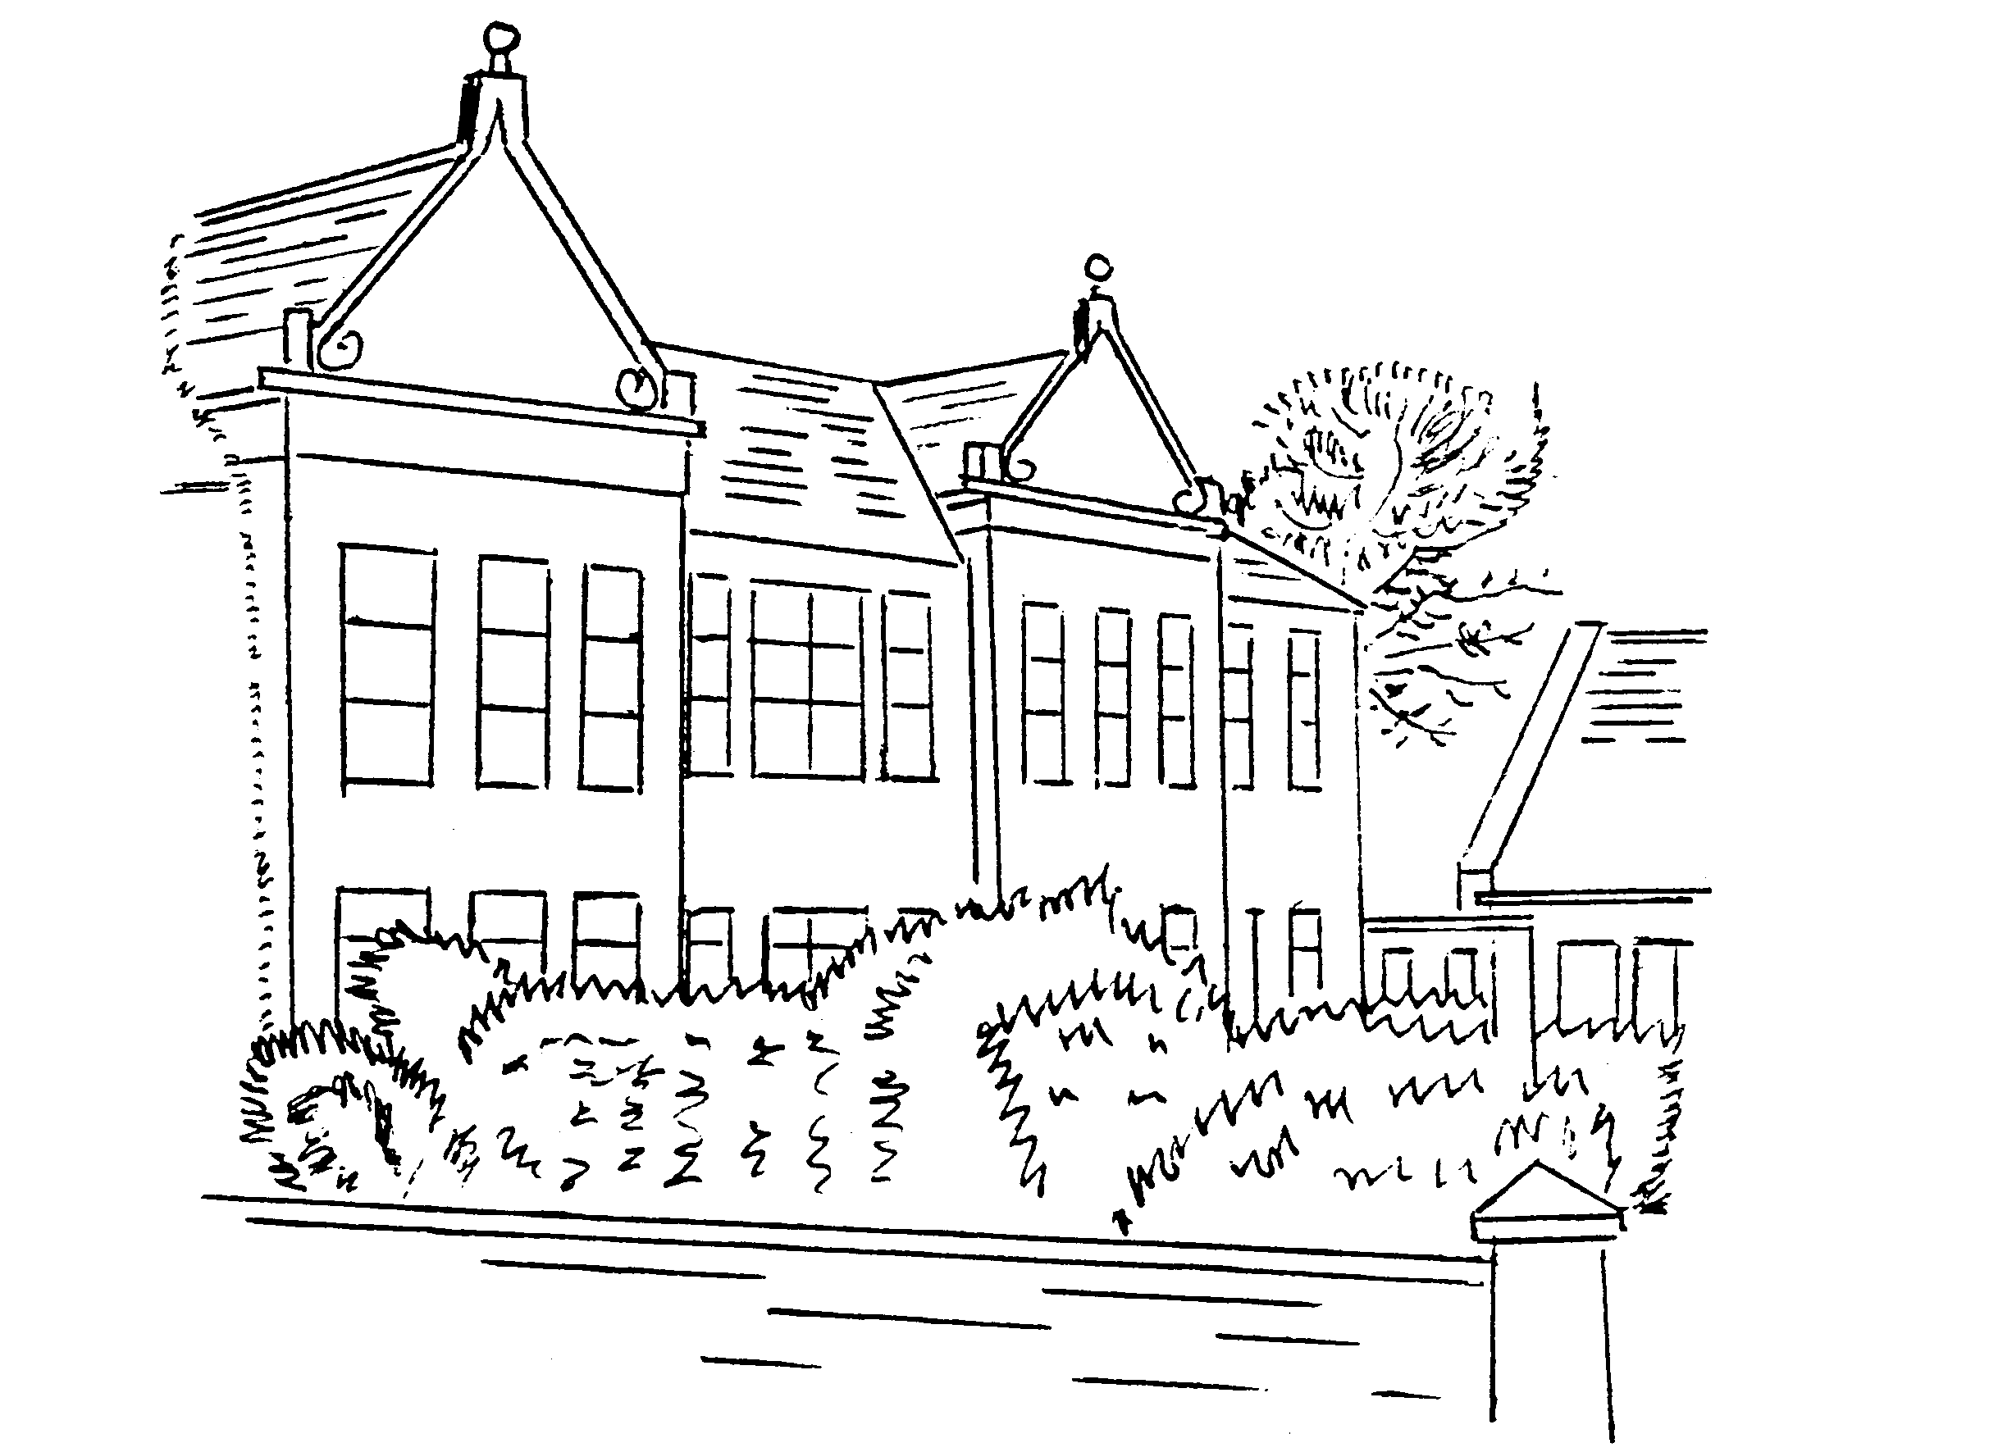

Ready, Respectful, Safe
Better Behaviour Better Learning
This policy has been drawn up in consultation with staff,
Pupil Council and Torphins School Partnership Group.

Rev 1 October 2016
Rev 2 March 2019
Rev 3 November 2019
Rev 4 March 2020

Learning Together Anything’s Possible

Article 12 Children have the right to say what they think should happen, when adults are making decisions that affect them, and to have their opinions taken into account.

Article 31 All children have the right to relax and play, and to join in a wide range of activities.

Torphins Primary School
Vision, Values and School Ethos

- We are a UNICEF Rights Respecting School and as Effective Contributors and Responsible Citizens we uphold its values.

- We embrace challenge and try our best in everything we do to become Successful Learners and Confident Individuals.

- Our school aims to make learning meaningful, appropriate to individual needs and enjoyable.

- We celebrate success and achievement gained both in school and in our wider community.

- We are proud of our school.
Article 29 Education should develop each child’s personality and talents to the full. It should encourage children to respect their parents, their own and others’ cultures.

Article 28 All children have a right to primary education which should be free. Wealthy countries should help poorer countries achieve this. Discipline in schools should respect children’s dignity. Young people should be encouraged to reach the highest level they are capable of.

Article 24 Children have a right to good quality health care, to clean water, nutritious food, and a clean environment, so that they will stay healthy.

The Ready, Respectful, Safe approach enables us, as a partnership with pupils and parents, to fulfil our stated aims by providing an appropriate ethos for a successful learning environment.

Better Behaviour, Better Learning
At Torphins Primary School we have high expectations of good behaviour as this has a positive impact on the learning and attainment of the children.
As a partnership, pupils, parents and staff work together to develop a caring, inclusive and considerate environment where all children feel happy, safe and ready to learn.

As self-discipline is at the heart of effective learning and teaching, at Torphins Primary School everyone is encouraged to show respect for others and take responsibility for their own actions and behaviour.
There is an emphasis on promoting good behaviour and positive relationships so that we can enable our pupils to become
- responsible citizens
- successful learners
- effective contributors
- confident individuals

Our Aims
- Encourage pupils to take a pride and interest in their school through active participation in decisions affecting them and their local community.
- Self-discipline is at the heart of effective learning and pupils are encouraged to be responsible for their own behaviour and actions.
- Work in partnership with our pupils and parents to create a pleasant, caring, secure, stimulating and happy environment where positive behaviour is promoted.
- A Ready, Respectful, Safe approach is used to promote high expectations of better behaviour, better learning. Are you Ready to learn? Are you being Respectful? Are we all working together to keep our school Safe?
- Work in partnership with outside agencies as appropriate to support children and their families.

A Restorative Approach
This approach aims to resolve disagreements and manage inappropriate behaviour. This is achieved by communicating at an appropriate level to encourage empathy and reflection and focus on repairing relationships to reach a resolution.

Throughout the School
All staff are collectively responsible for positive behaviour modelling and management of children throughout the school using our agreed Ready, Respectful, Safe approach. Each class has a Ready, Respectful, Safe Class Charter, and there are Playground and Lunch Hall Charters, to help create a Rights Respecting environment throughout the school.

Teachers
Each teacher is also directly responsible for the pupils in their class or lesson. Their influence is vitally important and they actively promote the school’s high expectations of good behaviour, positive relationships and commitment to learning. It is anticipated that in normal circumstances these measures will be sufficient. If, however, this is not the case the Class Teacher will contact parents to discuss any underlying cause that the school may not be aware of and agree an appropriate course of action.

In the Playground
Positive relationships and feelings of wellbeing are promoted through the Playground Charter and regularly reinforced and supported by all staff.
- This is supported by Pupil Support Assistants who ensure the playground is a secure and safe environment where everyone is respected, and the children can relax and play.
- Unacceptable behaviour is discussed using a restorative approach with clear consequences if expectations are not met.
- Pupil Support Assistants support the development of positive behaviour by listening to worries and encouraging sharing and inclusion in games.
- When appropriate the PSA will inform the Class Teacher of any behaviours giving rise for concern. The Class Teacher will then follow the appropriate course of action which may include contacting parents.
The Role of Senior Management
If behaviour proves to be significantly challenging for individual children, the related incidents will be dealt with by the Senior Management Team.

In accordance with Aberdeenshire Council guidelines, extreme cases of indiscipline may result in the pupil being suspended from school. This normally follows when every form of support has been tried and parents have been involved. When appropriate this will be in consultation with the QIO, who is a senior educational officer from the area office. Exclusion is seen as a last resort.

